HANDOUTS MGT430
LECTURE #09
Creativity Techniques
Creativity is the ability to generate new innovative ideas and concepts. The process involves original thinking or making connections between ideas to produce something new. Creativity can be the re-combination of known elements into something new by producing valuable solutions to existing controversy or problem by generating new ideas. Creativity is the process, not the product. Creativity can be systematic and unsystematic that may involves both types of thinking conscious and sub conscious. Techniques are the procedures of executing or carrying out a particular task. Creativity Techniques or creativity methods think up solutions to problems. Creativity techniques are trial and error methods to ignite creativity in individual or a group of people. Creativity techniques encourage creative actions and focus on a variety of aspects for idea generation, methods of re-framing problems, and divergent thinking. Creative techniques are useful to generate large amount of ideas in a short time. Following are different creativity techniques like Brainstorming, Mind Mapping, Rapid Prototyping, Mix n Match (Thomas Edison Challenge) and Attribute Listing Chart to generate ideas.

Brainstorming:
Brainstorming is group discussion to solve problems or produce ideas. The group based problem-solving technique involves the spontaneous contribution of large quantity of novel and imaginative ideas from all members of the group. In Brainstorming one or more individuals mull over ideas in an attempt to devise or find a solution to a problem.

Figure 1: Brainstorming technique to generate creative ideas
Brainstorming Guidelines
Brainstorming follows certain guidelines, (1) keep the group small “Two pizza rule”, (2) Make the group as diverse as possible, (3) Company rank is irrelevant, (4) Have a well-defined problem, but don’t reveal it ahead of time, (5) Limit the session to 40 to 60 minutes, (6) Take a field trip, (7) Appoint a recorder, (8) Use a seating pattern that encourages interaction, (9) Throw logic out the window, (10) Encourage all ideas from the team, (11) Shoot for quantity of ideas over quality of ideas, (12) Forbid criticism, (13) Encourage idea “hitch-hiking” and Dare to imagine the unreasonable.
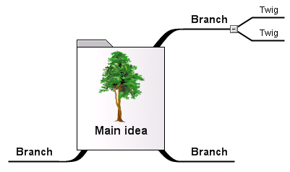
Mind-mapping:
Mind Mapping is a graphical technique that encourages thinking on both sides of the brain. Mind Mapping visually displays relationships among ideas and improves the ability to see a problem from many sides. Mind mapping is a logical and creative means of note-making and note-taking that literally "maps out" your ideas. Mind map “maps” out thinking based on a central idea. To create a mind map, simply start with a central theme, idea, or topic indicated as a “Subject” in the form of bubble. After central Theme or Subject create parent/child branches. Parent/child tree branches flow from topic i.e. “Subject” into Ideas and eventually subtopics. The main goal is to understand, organize and associate ideas related to a topic individually and sort them from largest to smallest.
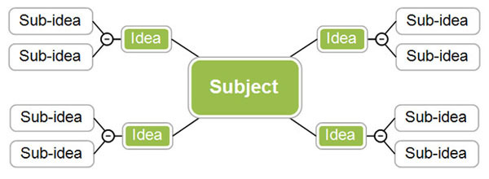
Figure 2: Mind Map Illustration

Mind Mapping- How to Draw?
Take a large sheet of paper and place it horizontally in front of you. Write the text or Draw a reasonably sized (colored) memorable central image that represents the topic you are going to be mapping. Draw thick organic looking branches radiating outwards from the central image. Make sure to use a different color to represent each branch. Write key-topic words along these branches that represent the central image and the topic you are mapping. Draw additional branches that extend from your main branches. The words on these branches are sub-topics of the words you wrote on your main branches. Keep expanding the mind map outwards with additional sub sub-topics/keywords and branches. Following is the graphical examples of mind mapping, how to mind map.
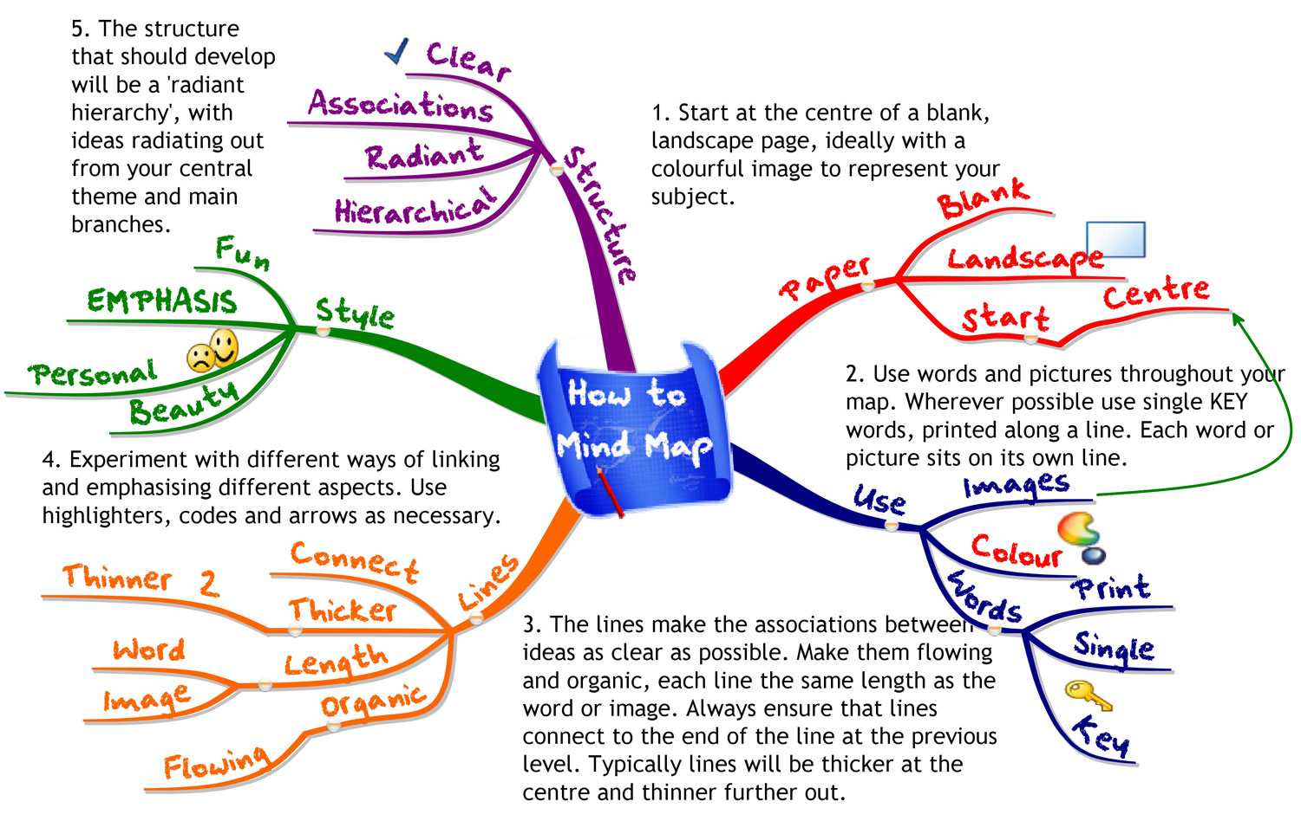
Figure 3: Mind Map practical Example: How to Mind-Map
Mix n Match (Thomas Edison):
Mix and Match technique is mixing and matching of systems, products or processes through all possible combinations to check either these combination bring something new to ignite novel system, product or process. Following table contains twenty products, ten products on each side of the table in list A and B. For example adding perfume from list A to insect killer from List i.e. make Mortein Aromatic. So, Instead of buying Air freshener and Mortein separately, the new combination appeals to buy two in one. Adding insect killer spray from list B to Perfume from list A can produce new product having mosquito’s repellent properties. Everybody will love to buy such perfumes who want to save their selves from mosquitos. New proposed combinations are provided at the right side of the product table with unique and innovative ideas.
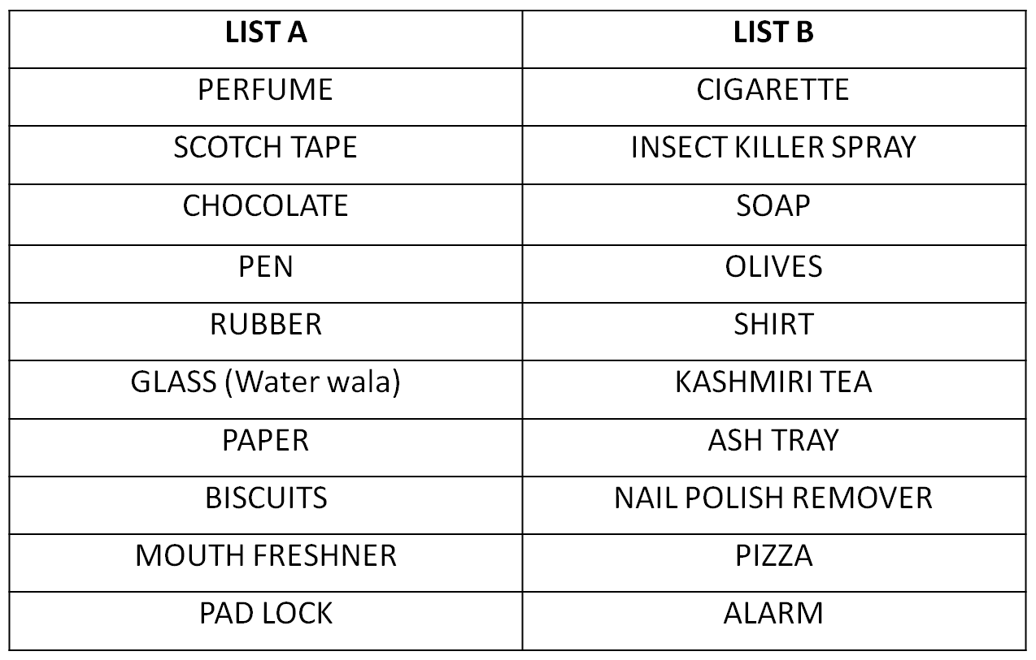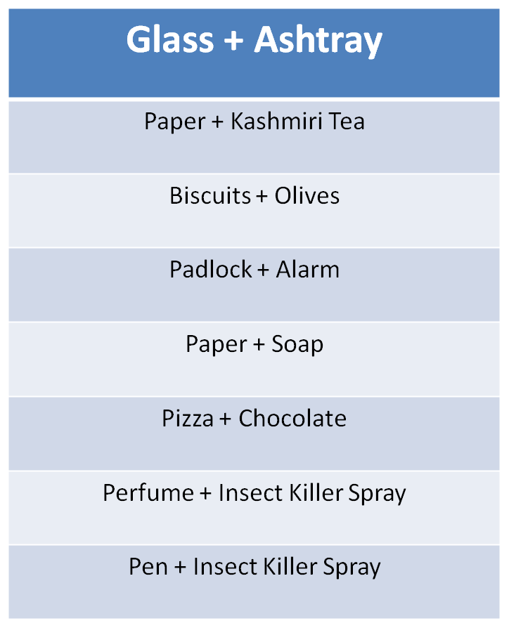

Figure 4: Mix and Match Table and Proposed New Combinations
Following windshield wonder, Pillow pets and storage cutter are really creative and innovative successes stories of Mix and Match creative technique:

Windshield Wonder:
This Mix and Match creative technique solved the problem of millions by cleaning the windshield crevas through Shammy on a Stick.

Pillow Pets:

This mix and match technique provides security and comfort to little kids by mixing pillow with a stuffed animal in the form of PILLOW PETS.
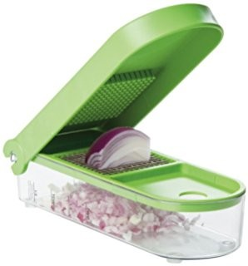
Storage Cutter:
This product is available in the market with so many names. Basically in this mix and Match technique the storage container is matched with a Knife and made millions of lives easier through this creative invention.

Rapid prototyping:
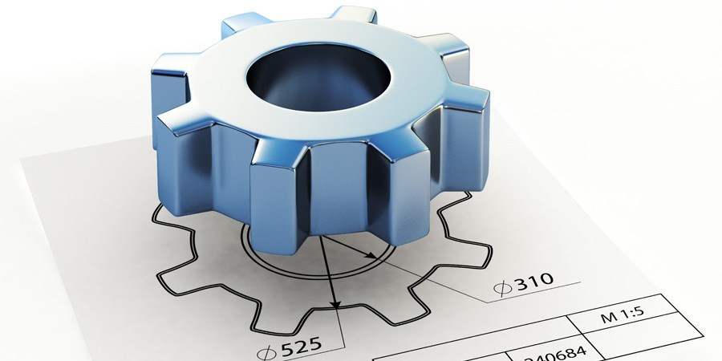
A prototype is an early sample or preliminary model of an idea, design, product, process, service, technology, interface, or creative work. A prototype is a draft version of a product built to test a concept or process before investing time and money in development but close to original product in functionality. It allows exploring new ideas, showing the intention behind overall design concept to users. Rapid prototyping is transforming an idea into an actual model where one can point out flaws that lead to design improvements. Here are some tips on rapid prototyping; (1) Start building even if you are not sure what you are doing?, (2) Don’t spend too long on one prototype and (3) Build prototype with the user in mind.

Attribute Listing Chart:
Attribute Listing is a creative technique developed by Robert Crawford during 1930s as an idea-generating tool to solve problems, find new ideas or innovative products and services by breaking down the problem into smaller parts and look for alternative solutions to these parts. It produces very positive results when used in combination with other creative techniques such as brainstorming or mind mapping. Attribute Listing can be used in various situations where problem is broken down into smaller parts and look for alternatives by using other creative methods. This technique is useful to find alternative solutions to existing problem expand and develop product ranges, new marketing approach - and many more. Attribute Listing can be successfully combined with other creative techniques like brainstorming and mind mapping to come up with new alternatives and imaginative solutions. This technique involves changing, modifying and improving attributes by listing down all the attributes, Consider value of attributes and modifies the values for respective attributes.

In Attribute listing list all of the attributes/components of the product, process, service, problem or strategy you are examining and then list all the possible alternatives to these components/attributes. Attributes are parts, properties, qualities or design elements of the thing being looked at. Draw up a table using these attributes as column headings. Write down as many variations of the attribute as possible within these columns. Now select one entry from each column. Either do this randomly or select interesting combinations. Let's look at a pencil as an example, the components or attributes of a pencil are:
Shaft material
Lead type
Hardness and width of lead
Quality
Colour
Weight
Price, etc.
List down all of the alternatives to these components in a table and mix the alternatives generated to find a new innovative product or service as follows in the table.
Figure 5: Attribute Listing Table for Pencil
This technique can be applied in variety of situation where modification/improvement of product, process, or service is needed or to examine essential problem- related attributes or to reduce or eliminate the problem. Attribute Listing could be used in situations like new competition, new technology, new customer preference etc. to find a new or adjust the existing position of a product in the market. The combination of this method with brainstorming session is very useful and productive. The core idea is to “forget/unlearn/unfreeze” everything you have learned and retained in the past when thinking about a possible solution. Follow rules (1) “break up” product, service or system “into its elements”, (2) ask about: “necessary/mandatory element of an object or a structure to properly function, (3) characteristics/attributes of elements (form, material etc.), (4) Any other way and possibilities to create this element?, and (4) Elements and possible attributes must be listed in a table.
At the end one might arrive at surprising “compositions” from the table, which will lead to completely new products, services and structures after trial and error method.

Conclusion:
Schumpeter Theory changed the paradigm of entrepreneurship research by proposing creativity and innovation as an integral part of entrepreneurship. Creativity is the ability to generate new innovative ideas and concepts through creativity techniques. Creativity techniques are trial and error methods to ignite creativity in individual or a group of people. This Lecture discussed different creativity techniques like Brainstorming, Mind Mapping, Rapid Prototyping, Mix n Match (Thomas Edison Challenge) and Attribute Listing Chart. Brainstorming is group discussion to solve problems or produce ideas. The group based problem-solving technique involves the spontaneous contribution of large quantity of novel and imaginative ideas from all members of the group. Mind Mapping is a graphical technique that encourages thinking on both sides of the brain. Mind Mapping visually displays relationships among ideas and improves the ability to see a problem from many sides. Rapid prototyping is transforming an idea into an actual model where one can point out flaws that lead to design improvements. Mix and Match technique is mixing and matching of systems, products or processes through all possible combinations to check either these combination bring something new to ignite novel system, product or process. Attribute Listing can be used in various situations where problem is broken down into smaller parts and look for alternatives by using other creative methods. This technique is useful to find alternative solutions to existing problem i.e. to expand and develop product ranges, new marketing approach - and many more. Attribute Listing can be successfully combined with other creative techniques like brainstorming and mind mapping to come up with new alternatives and imaginative solutions.

